Software Requirements Specification

for

eCommerce Website-Car Services

Version 1.0 approved

Prepared by Karan Shah (A20392253)

Ajay Mukhi (A20392100)

Project Group 2

28th February,2018

Contents

1. Introduction 3

1.1 Purpose 3

1.2 Scope 3

2. Features 3

3. Technology Recommended 4

4. Requirements Table 4

5. UML Diagrams 7

5.1 Entity Relationship Diagram 7

5.2 SQL Commands (from ERD) 7

5.3 Architecture Diagram 13

5.4 Use case Diagram 14

5.5 Class Diagram 15

6. Web Services APIs 15

7. Conclusion 16

# Introduction

The introduction of the Software Requirements Specification (SRS) provides an overview of the various points such as purpose, scope, overview of this document. The aim of this document is to gather and provide scope of the eCommerce website.

## Purpose

The purpose of this document is to collect and analyze the requirements of the eCommerce website. We will list down the requirements to have a better understanding of the project. In short, purpose of this SRS document is to provide a detail overview of our software, its goals, its database structure, visualize the product with respect to various diagrams such as Architecture diagram, UML diagram, etc. This document describes the project's target audience and its user interface, hardware and software requirements

## Scope

The scope of the project is to develop website with various features such as sign up, sign in, search products, checkout, contact provider, etc. The website will have 3 different types of user: 1) Customer 2) Provider and 3) Admin. More details on the each of the user types have been given in the below sections. The eCommerce website is a platform through which car owners can list their cars for sell, customers can view these cars, dealers can add the products like Fender, Exterior door handle, Interior door handle, etc. Customers will have an option to order these products online by making an online payment through PayPal. The below sections provide more detail information on each of the feature.

# Features

The eCommerce website will have following 3 roles:

1. **Customer**: Customer is one who can browse the website and search for the different products. They will have feature to view the cars uploaded by the providers and contact them via a contact form. Moreover, they can also view the different products added by the providers like window switch, door handle, wiper, etc. Option for the customer to search for the products and filter them with different search filters. Customers can make an online purchase of the different car parts. Payment for the online purchase will be done via PayPal.
2. **Providers**: Providers are the ones who will upload the car for sell as well as will have an option to upload car parts to which customers can make an online payment. Providers will have a form to add car for sell as well as a form to upload car parts for sell.
3. **Administrator**: Admin will be responsible to maintain the different activity going across the website. They can delete the user account as well as option to delete the products from the website

# Technology Recommended

|  |  |
| --- | --- |
| **Programming Language** | JAVA |
| **Relational Database** | MySQL |
| **Web Server** | Apache Tomcat |

# Requirements Table

The following table will provide detail information on the requirements for this eCommerce website:

|  |  |  |  |  |
| --- | --- | --- | --- | --- |
| **Requirement ID** | **Module Name** | **Sub Module** | **Tasks** | **Priority** |
| Req_1 | Front End | Home Page | Navigation to different menus - User can navigate to different menus | High |
|  | **Customer Profile** | |  |
| Req_2 | Sign up | Customers can sign up into the profile using following fields: - First Name - Last Name - Email Address - Password - Confirm Password - Contact No. | High |
| Req_3 | Sign up with social media | Customers can sign up using Facebook | Low |
| Req_4 | Login | Customers can login using Email Address and password | High |
| Req_5 | Forgot Password: - Customers need to enter their email address and forgot password will be emailed to their email address from which they can set updated password | High |
| Req_6 | Product Browsing (cars and car parts) | Category Browsing | High |
| Req_7 | Search Product | High |
| Req_8 | Product Listing -Sort by -Filter listing | High |
| Req_9 | Send Inquiry | Customers can send an inquiry to car owner/provider expressing his interest in the car - Form with some 3-4 fields will be provided and on submission, car owner/provider will receive an email | High |
| Req_10 | My Cart | Customers can make an online payment for the buying the car parts. | High |
| Req_11 |  | Add/Edit/Delete product to/from cart | High |
| Req_12 | Update cart | High |
| Req_13 | Checkout Process -Billing information -Shipping information -Payment information -Order review | High |
| Req_14 | Payment Gateways | High |
| Req_15 | My Account | My Orders -Order history | High |
|  | **Provider Profile** | |  |
| Req_17 | Sign up | Customers can sign up into the profile using following fields: - First Name - Last Name - Email Address - Password - Confirm Password - Contact No. | High |
| Req_18 | Sign up with social media | Customers can sign up using Facebook | Low |
| Req_19 | Login | Customers can login using Email Address and password | High |
| Req_20 | Forgot Password: - Customers need to enter their email address and forgot password will be emailed to their email address from which they can set updated password | High |
| Req_21 | Add Car for Sell | Provider can add following details to add car for sale: - Add Car Model - Add Fuel Type - Kms Driven - Add description - Upload Images | High |
| Req_22 | View Details | View/Edit/Delete details | High |
| Req_23 | Add Car Parts for Sell | Provider can add following details to add car parts for sell: - Add Parts Name - Add description - Upload Images - Add Price Range | High |
| Req_24 | View details | View/Edit/Delete details | High |
| Req_25 | View Products sold | Providers can view the products bought by the customers. | High |
| Req_26 | My Account | My Orders -Order history | High |
| Req_27 | **Admin Panel** | Admin Log in | User name/ Password | High |
| Req_28 | Sales Management | Order Management  List Order | High |
| Req_29 | Catalogue Management | Edit/Delete Products added by the provider | High |
| Req_30 | Customers | Manage Customers/Providers | High |
| Req_31 | **System Testing** | System Testing |  | High |

# UML Diagrams

## Entity Relationship Diagram

## SQL Commands (from ERD)

CREATE TABLE Customer

(

customer_id INT NOT NULL,

first_name INT NOT NULL,

last_name INT NOT NULL,

phone_number INT NOT NULL,

email INT NOT NULL,

PRIMARY KEY (customer_id)

);

CREATE TABLE Cars

(

car_id INT NOT NULL,

serial_number INT NOT NULL,

model_number INT NOT NULL,

car_type INT NOT NULL,

customer_id INT NOT NULL,

PRIMARY KEY (car_id),

FOREIGN KEY (customer_id) REFERENCES Customer(customer_id)

);

CREATE TABLE car_model

(

make INT NOT NULL,

model_number INT NOT NULL,

model_name INT NOT NULL,

year INT NOT NULL,

color INT NOT NULL,

PRIMARY KEY (model_number)

);

CREATE TABLE user

(

user_id INT NOT NULL,

user_name INT NOT NULL,

user_contact INT NOT NULL,

user_email INT NOT NULL,

user_address INT NOT NULL,

customer_id INT NOT NULL,

PRIMARY KEY (user_id),

FOREIGN KEY (customer_id) REFERENCES Customer(customer_id)

);

CREATE TABLE login

(

login_id INT NOT NULL,

login_userid INT NOT NULL,

login_password INT NOT NULL,

customer_id INT NOT NULL,

PRIMARY KEY (login_id),

FOREIGN KEY (customer_id) REFERENCES Customer(customer_id)

);

CREATE TABLE Payment

(

payment_id INT NOT NULL,

payment_type INT NOT NULL,

card_number INT NOT NULL,

address_id INT NOT NULL,

order_id INT NOT NULL,

PRIMARY KEY (payment_id)

);

CREATE TABLE address

(

address_id INT NOT NULL,

address1 INT NOT NULL,

country INT NOT NULL,

city INT NOT NULL,

state INT NOT NULL,

zipcode INT NOT NULL,

customer_id INT NOT NULL,

PRIMARY KEY (address_id),

FOREIGN KEY (customer_id) REFERENCES Customer(customer_id)

);

CREATE TABLE Has

(

car_id INT NOT NULL,

model_number INT NOT NULL,

FOREIGN KEY (car_id) REFERENCES Cars(car_id),

FOREIGN KEY (model_number) REFERENCES car_model(model_number)

);

CREATE TABLE purchase

(

order_id INT NOT NULL,

customer_id INT NOT NULL,

car_id INT NOT NULL,

part_id INT NOT NULL,

payment_id INT NOT NULL,

PRIMARY KEY (order_id),

FOREIGN KEY (payment_id) REFERENCES Payment(payment_id)

);

CREATE TABLE car_buy

(

car_id INT NOT NULL,

order_id INT NOT NULL,

FOREIGN KEY (car_id) REFERENCES Cars(car_id),

FOREIGN KEY (order_id) REFERENCES purchase(order_id)

);

CREATE TABLE order

(

customer_id INT NOT NULL,

order_id INT NOT NULL,

FOREIGN KEY (customer_id) REFERENCES Customer(customer_id),

FOREIGN KEY (order_id) REFERENCES purchase(order_id)

);

CREATE TABLE Parts

(

part_id INT NOT NULL,

part_name INT NOT NULL,

description INT NOT NULL,

price INT NOT NULL,

quantity INT NOT NULL,

order_id INT,

PRIMARY KEY (part_id),

FOREIGN KEY (order_id) REFERENCES purchase(order_id)

);

CREATE TABLE Dealer

(

dealer_id INT NOT NULL,

dealer_name INT NOT NULL,

authorization_id INT NOT NULL,

contact_no INT NOT NULL,

login_id INT NOT NULL,

car_id INT NOT NULL,

part_id INT NOT NULL,

PRIMARY KEY (dealer_id),

FOREIGN KEY (login_id) REFERENCES login(login_id),

FOREIGN KEY (car_id) REFERENCES Cars(car_id),

FOREIGN KEY (part_id) REFERENCES Parts(part_id)

);

## Architecture Diagram

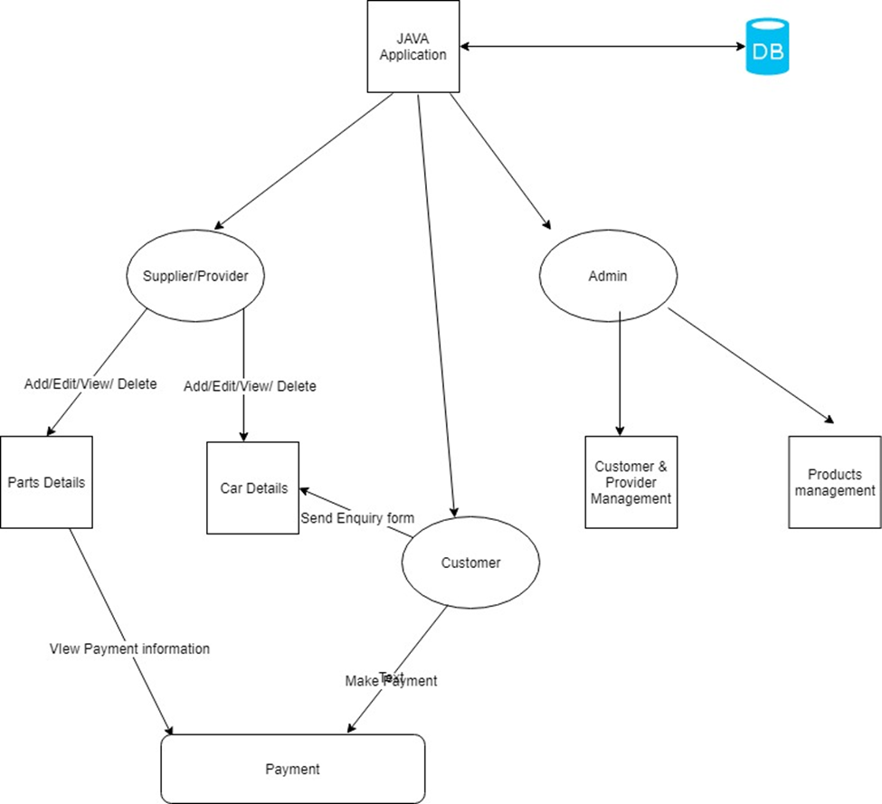

## Use case Diagram

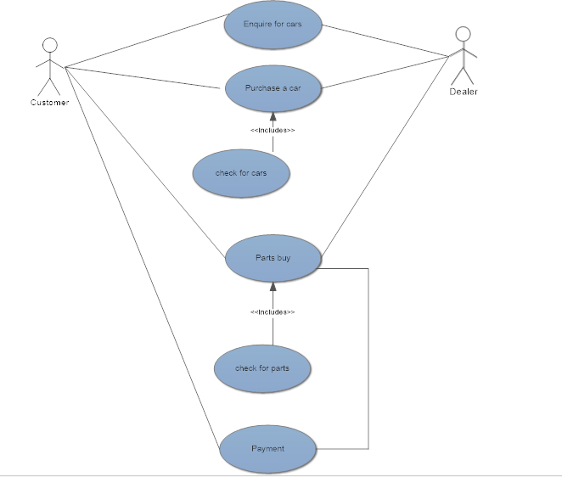

## Class Diagram

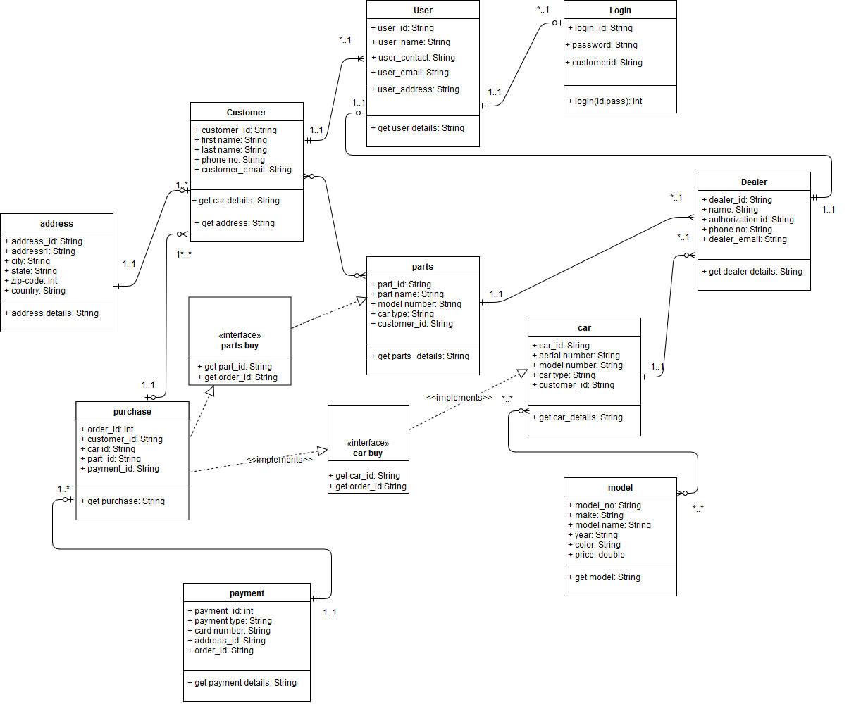

# Web Services APIs

ArrayList<String> getCarDetails (String modelno, String type);

ArrayList<String> getCarByModel (String modelno);

ArrayList<String> getCarByMake (String make);

String getInvoice (String customer);

String getCustomerDetails (String customerid);

String makePayment (String orderid, float amount);

String loginUser(String userid);

ArrayList<String> getPartsDetails(String part name, String part_type);

ArrayList<String,String> getaddressDetails(String custid);

ArrayList <String> orderDetails(String order id,String cust id);

# Conclusion

The eCommerce website will be of a great benefit to the customers to purchase the cars parts online from the providers and enquire about the cars just by filling up an enquiry form. On the other hand, it will also be a great platform for the providers to easily sell their car parts and cars from the website.